Konferans Bildirisi
Makale Başlığınızı Yazınız
Ad Soyad¹*, Ad Soyad²
¹ Kurumunuz, Orcid ID: https://orcid.org/xxxx-xxxx-xxxx-xxxx orcid id bu formatta yazılmalı, E-mail: xxxxxx@xxx,
² Kurumunuz, Orcid ID: https://orcid.org/xxxx-xxxx-xxxx-xxxx orcid id bu formatta yazılmalı, E-mail: xxxxxx@xxx
* Sorumlu Yazar: e-mail@e-mail.com; Tel.: (opsiyonel)

Received 12 December 2023
Received in revised form 16 January 2024
Accepted 15 February 2024

4th International Conference on Access to Recent Advances in Engineering and Digitalization
May 27 - 28, 2024
Reference: will be edited by editorial
Özet
Xxxxxxxxxxxxxxxxxxxxxxxxxxxxxxxxxxxxxxxxxxxxxxxxxxxxxxxxxxxxxxxxxxxxxxxxxxxxxxxxxxxxxxxxxxxxxxxxxxxxxxxxxxxxxxxxxxxxxxxx.xxxxxxxxxxxxxxxxxxxxxxxxxxxxxxxxxxxxxxxxxxxxxx.
Anahtar: xxxx, xxxx, xxxx
Conference Article
Write Your Paper Title (İngilizce Başlık ve İngilizce Özet Mutlaka Olmalı)
Name Surname^{1*}, Name Surname²
¹ Affiliation 1, Orcid ID: https://orcid.org/xxxx-xxxx-xxxx-xxxx, E-mail: xxxxxx@xxx
² Affiliation 2, Orcid ID: https://orcid.org/xxxx-xxxx-xxxx-xxxx, E-mail: xxxxxx@xxx
* Correspondence: e-mail@e-mail.com; Tel.: (optional; include country code)

Received 12 December 2023
Received in revised form 16 January 2024
Accepted 15 February 2024

4th International Conference on Access to Recent Advances in Engineering and Digitalization
May 27 - 28, 2024
Reference: will be edited by editorial
Abstract
Xxxxxxxxxxxxxxxxxxxxxxxxxxxxxxxxxxxxxxxxxxxxxxxxxxxxxxxxxxxxxxxxxxxxxxxxxxxxxxxxxxxxxxxxxxxxxxxxxxxxxxxxxxxxxxxxxxxxxxxx.xxxxxxxxxxxxxxxxxxxxxxxxxxxxxxxxxxxxxxxxxxxxxx.
Keywords: Xxxx, xxxx, xxxx
- Giriş
Xxxxxxxxxxxxxxxxxxxxxxxxxxxxxxxxxxxxxxxxxxxxxxxxxxxxxxxxxxxxxxxxxxxxxxxxxxxxxxxxxxxxxxxxxxxxxxxxxxxxxxxxxxxxxx [1].
- Materyal ve Yöntem
Xxxxxxx.
Tablo 1: Deneme Data
Variables | Levels
Fabric composition | 96% cotton - 3% polyester - 1% elastane
Chemical | A, B
Xxxxxxxxxxxxxxxxxxxxxxxxxxxxxxxxxxxxxxxxxxxxxxxxxxxxxxxxxxxxxxxxxxxxxxxxxxxxxxxxxxxxxxxxxxxxxxxxxxxxxxxxxxxxxxxxxxxxxxxxxxxxxxxxxxxxxxxxxxxxxxxxxxxxxx
xxxxxxxxxxxxxxxxxxxxxxxxxxxxxxxxxxxxxxxxxxxxxxxxxxxxxxxxxxxxxxxxxxxxxxxxxxxxxxxxxxxxxxxxxxxxxxxxxxxxx.
  - Alt Başlık
Xxxxxxxxxxxxxxxxxxxxxxxxxxxxxxx.

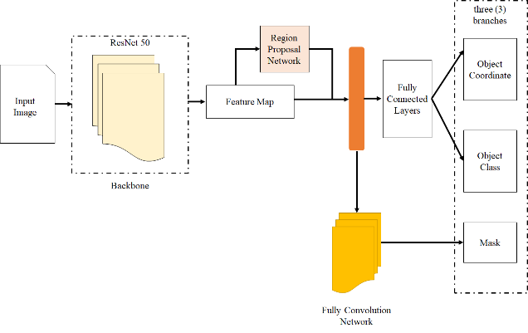
Şekil 1: Xxxxx Xxxxx
- Sonuçlar
Xxxxxxxxxxxxxxxxxxxxxxxxxxxxxxxxxxxxxxxxxxxxxxxxxxxxxxxxxxxxxxxxxxxxxxxxxxxxxxxxxxxxxxxxxxxxxxxxxxxxxxxxxxxxxxxxxxxxxxxxxxxxxxxxxxxxxxxxxxxxxxxxxxxxxxxxxxxxxxxxxxxxxx.
- Tartışma
Xxxxxxxxxxxxxxxxxxxxxxxxxxxxxxxxxxxxxxxxxxxxxxxxxxxxxxxxxxxxxxxxxxxxxxxxxxxxxxxxxxxxxxxxxxxxxxxxxxxx.
- Teşekkür
Xxxxxxxxxxxxxxxxxxxxxxxxx.
Referanslar
- IEEE Stili kullanılacaktır.
- Xxxxxxxx.
- Xxxxxxxxxxxx.

